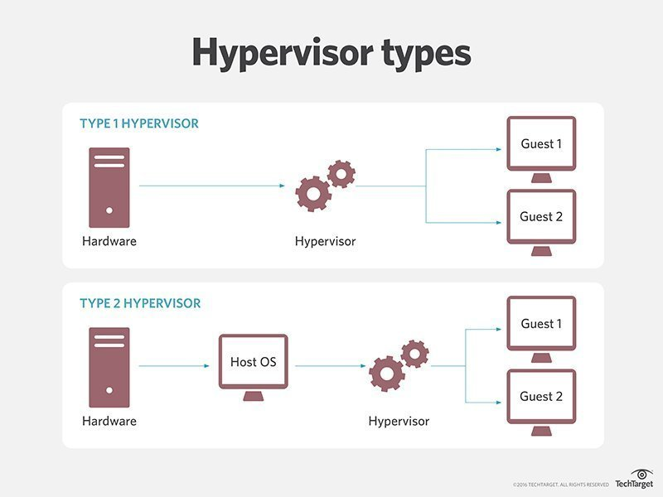

Difference between type 1 and type 2 hypervisor:

|  |  |
| --- | --- |
| Type 1 hypervisor | Type 2 hypervisor |
| 1.A Type 1 hypervisor runs directly on the host machine's physical hardware, and it's referred to as a **bare-metal hypervisor**.(Hardware level) | 1. It is called a **hosted hypervisor** because it relies on the host machine's pre existing OS to manage calls to CPU, memory, storage and network resources.(Os level) |
| 2. Type 1 hypervisors are regarded as the most efficient and best-performing hypervisors available for enterprise computing. | 2.The presence of an underlying OS with Type 2 hypervisors introduces unavoidable latency; all of the hypervisor's activities and the work of every VM has to pass through the host OS, so any security flaws or vulnerabilities in the host OS could potentially compromise all of the VMs running above it. |
| 3.These hypervisors require a separate management console to perform activities like instance creation, migration, etc. | 3.These hypervisors are hosted on the OS, and the hypervisor runs on that layer as another software to enable virtualization |
| 4.more secure | 4.Less secure |
| 5.Higher performance as there is no middleware | 5.Comparitavely has reduced performance rate as it runs with extra overhead |
| 6.More Resources +Overhead | 6.Less Resources + Less overhead |
| 7.VMvare ESxi,Microsoft Hyper-v | 8.Virtualbox , VMware workstation |
| 9. |  |
| 10.Type 1 hypervisors(vendors):  i. VMware vSphere: VMware vSphere is geared toward enterprise data centers; smaller businesses might find it difficult to justify the price.  ii. Microsoft Hyper-V: Microsoft Hyper-V runs on Windows OSes and enables admins to run multiple OSes inside a VM. Admins and developers often use Hyper-V to build test environments to run software on several OSes by creating VMs for each test.  iii. KVM: The KVM hypervisor is an open source virtualization architecture made for Linux distributions. Features include live migration, scheduling and resource control. | 10.Type 2 hypervisor products:  i.Oracle VM VirtualBox: Oracle VM VirtualBox is an open source hosted hypervisor that runs on a host OS to support guest VMs. VirtualBox offers multigeneration branched snapshots, Guest Additions, guest multiprocessing, ACPI support and Preboot Execution Environment network boot.  ii.VMware Workstation Pro and VMware Fusion: VMware Workstation Pro is a 64-bit hosted hypervisor capable of implementing virtualization on Windows and Linux systems.  VMware developed Fusion as an alternative to Workstation. VMware Fusion offers many of the same capabilities as Workstation but is macOS compatible and comes with fewer features at a reduced price.  iii.QEMU: QEMU is an open source virtualization tool that emulates CPU architectures and enables developers and admins to run applications compiled for one architecture on another. QEMU offers features such as support for non-volatile dual in-line memory module hardware, share file system, secure guests and memory encryption. |